Case Study 20: University Admission Decision Engine
1. Problem Statement
Evaluate candidates for a course using subject eligibility, aggregate marks and course-specific thresholds. Generate a ranked list of eligible candidates using tie-breaking rules.
2. Objectives
Check course-specific subject and aggregate requirements.
Reject candidates who fail any required condition.
Rank eligible candidates by aggregate, mathematics marks and application ID.
3. Assumptions
The course is B.Tech Computer Science.
Minimum aggregate is 80%, Mathematics must be at least 75 and Physics at least 70.
Ranking is based on aggregate percentage, then Mathematics marks, then ascending application ID.
4. Algorithm
Read candidate records.
Calculate aggregate percentage.
Check Mathematics, Physics and aggregate thresholds.
Add qualified candidates to an eligible list.
Sort the list using the tie-breaking rules.
Display rank and admission status.
5. Flowchart
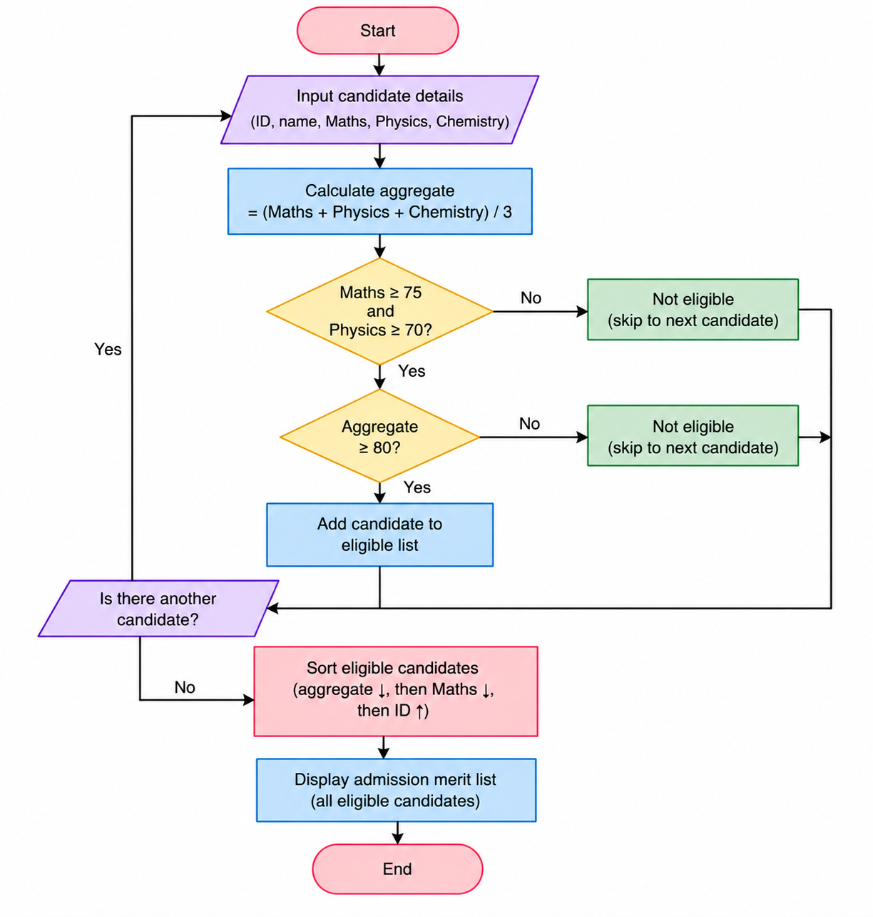
6. Pseudocode
START
Read candidate records.
Calculate aggregate percentage.
Check Mathematics, Physics and aggregate thresholds.
Add qualified candidates to an eligible list.
Sort the list using the tie-breaking rules.
Display rank and admission status.
Display result
STOP
7. Test Cases
Input / Record | Expected Result
C102 | Qualified; highest aggregate
C103 | Rejected; aggregate below 80
C101 | Qualified and ranked
8. Output Screenshot
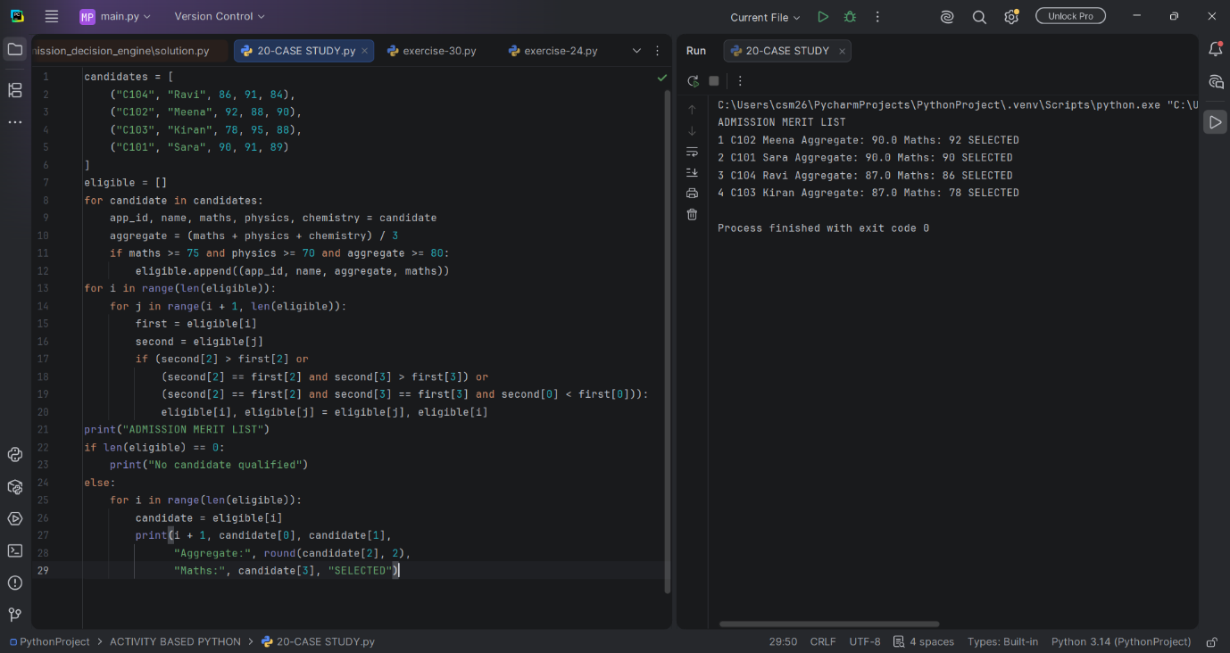
9. Conclusion
The program applies course eligibility rules and produces a deterministic merit list.

